EXP. NO: 22
SIMULATION AND ANALYSIS OF BPSK MODULATION USING CONSTELLATION DIAGRAMS IN MATLAB
Objectives:
1. To simulate Binary Phase Shift Keying (BPSK) modulation in MATLAB for a given binary data sequence.
2. To generate and analyze the BPSK constellation diagram and identify the two signal points corresponding to binary 0 and binary 1.
3. To study the effect of channel noise/AWGN on the BPSK constellation and evaluate signal quality using constellation parameters.
4. To compare the transmitted and detected symbols and determine the performance of the BPSK communication system.
Procedure:
1. Open the MATLAB software and create a new script file.
2. Clear the command window, workspace, and close all previously opened figure windows.
3. Generate a random binary data sequence.
4. Perform BPSK modulation by mapping the binary data into BPSK symbols.
5. Transmit the modulated signal through an Additive White Gaussian Noise (AWGN) channel.
6. Create a figure window to display the simulation results.
7. Plot the input binary data using a stem plot.
8. Plot the received BPSK symbols using a scatter plot to obtain the constellation diagram.
9. Label the axes appropriately and enable the grid for better visualization.
10. Execute the MATLAB program.
11. Observe the input binary sequence and the corresponding BPSK constellation diagram.
12. Analyze the distribution of the received symbols and verify the BPSK modulation characteristics.
PROGRAM:
Clc;
clear;
close all;
% Generate Random Bits
N = 100;
bits = randi([0 1],N,1);
% BPSK Modulation
bpsk = 2*bits - 1;
% 0 -> -1, 1 -> +1 % Add AWGN Noise
rx = awgn(bpsk,10,'measured');
% Constellation Diagram
figure;
subplot(2,1,1)
stem(bits)
title('Input Binary Data')
grid on
subplot(2,1,2)
scatter(real(rx), imag(rx),'filled')
title('BPSK Constellation Diagram')
xlabel('In-Phase')
ylabel('Quadrature')
grid on
axis([-2 2 -2 2])
Output:
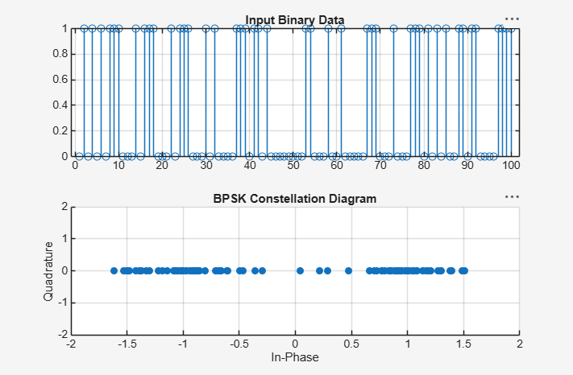
Result:
1. Generated a BPSK-modulated signal and its constellation diagram using MATLAB.
2. Identified the ideal BPSK constellation points and interpret their phase relationship.
3. Observed constellation spreading under AWGN/channel impairment.
4. Detected received BPSK symbols, compare them with transmitted symbols, and evaluate BER or symbol errors.

